Coding Challenge Medical Insurance Cost Analysis
- Find the total number of insurance records.
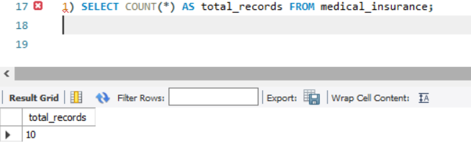
- Retrieve the details of all smokers above age 40.
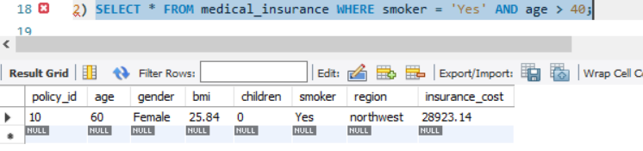
- Count how many male and female policyholders exist in the dataset.
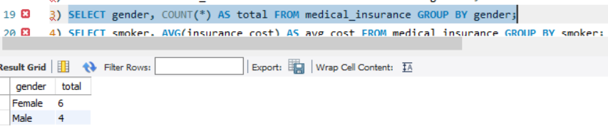
- Calculate the average insurance cost of smokers vs. non-smokers
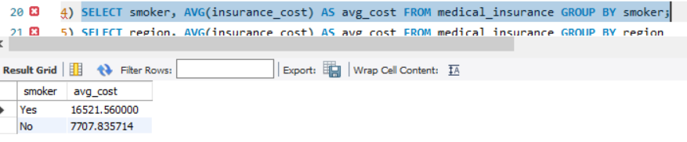
- Find the region with the highest average insurance cost
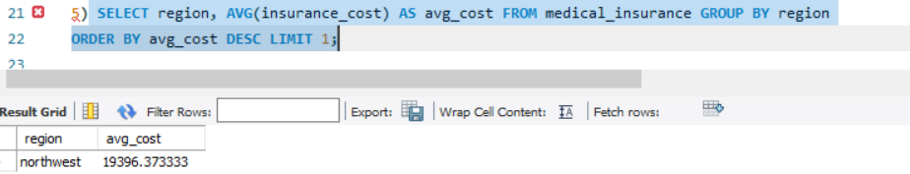
- List the top 5 policyholders who paid the highest insurance cost.
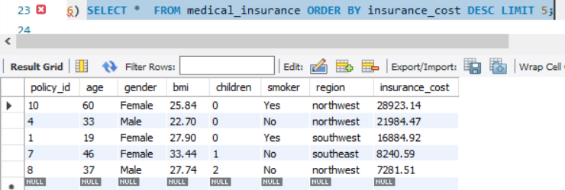

- Calculate the average insurance cost grouped by age group: o Young (18–30), Middle-aged (31–50), Senior (51+).
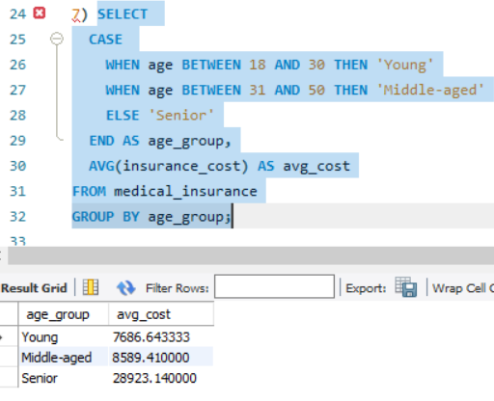
- Identify if smokers with BMI > 30 are paying significantly higher insurance than nonsmokers.
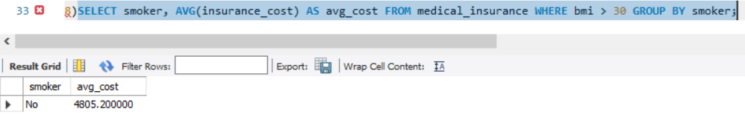
- Find the correlation-like insights (not actual correlation in SQL, but using GROUP BY)
- Avg cost by number of children.
- 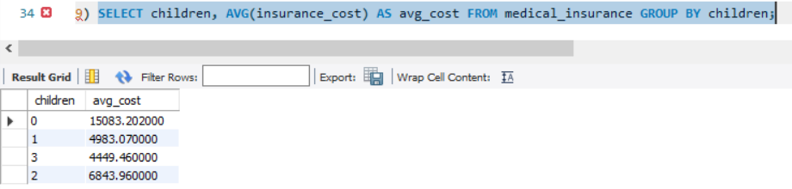
- Avg cost by gender.
- 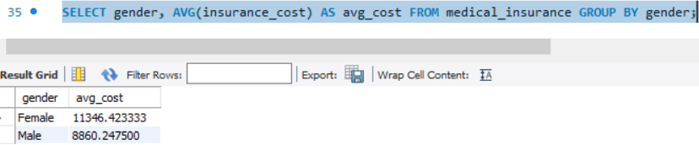

- Avg cost by region.
- 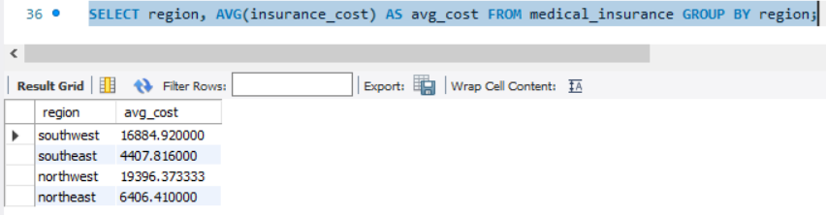
- Write a query to find the insurance cost difference between smokers and non-smokers in each region.
